# CS 255 System Design Document Template

## UML Diagrams

### UML Use Case Diagram

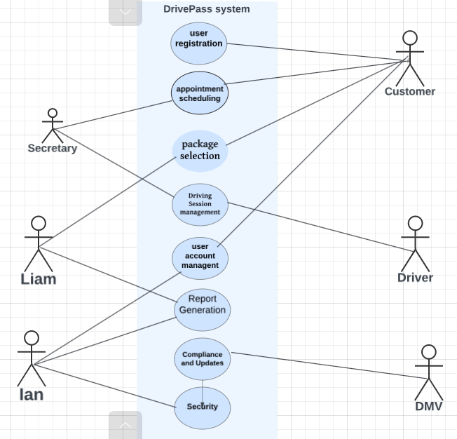

### UML Activity Diagrams

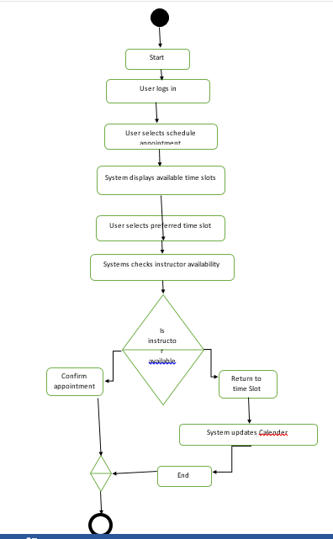

### UML Sequence Diagram

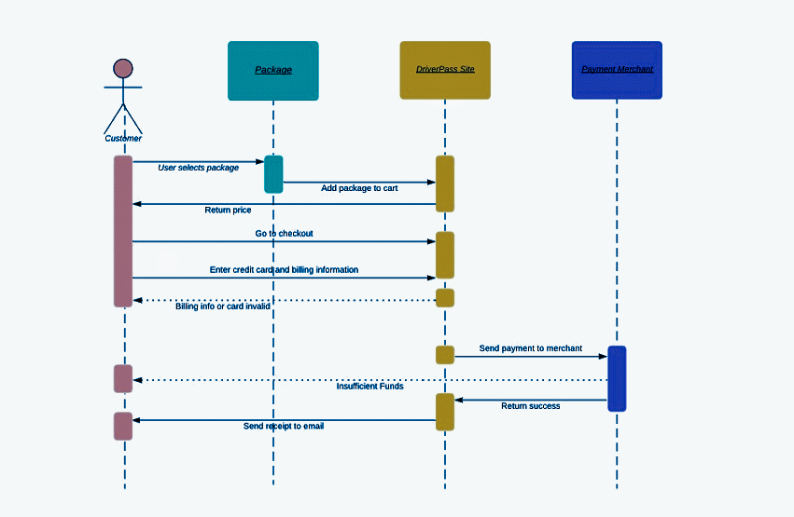

### UML Class Diagram

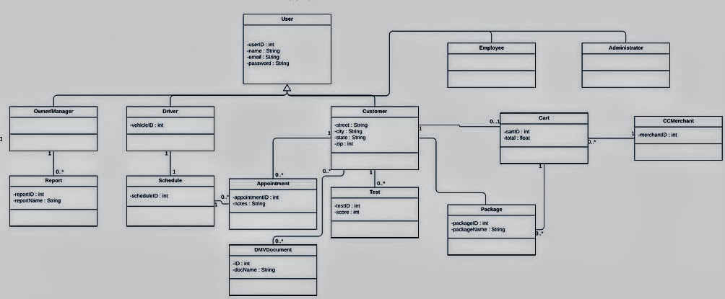

## Technical Requirements

Here are the hardware, software, tools, infrastructure and additional requirements needed for DrivePass;

**Hardware Needs**

* Servers, for hosting the DrivePass website and managing user requests
* Database servers to store user data package information and transaction records
* Hardware for payment processing during financial transactions

**Software Needs**

* A web application framework to develop the DrivePass site.
* Database management system to store and retrieve data.
* User authentication and authorization system for role based access control management.
* Integration of a payment gateway for transaction processing.
* Email service to send receipts and notifications to users.
* Encryption software to secure data both at rest and in transit.

**Tools Required**

* An Integrated Development Environment (IDE) for coding the web application.
* Version control systems like Git to manage code changes efficiently.
* UML modeling tool for creating and updating system diagrams.
* Testing tools to ensure functionality and security measures are in place.
* Project management software for tracking development progress.

**Infrastructure Setup**

* Utilization of a cloud hosting platform ensures scalability and reliability of services.
* Incorporation of load balancers distributing traffic among servers effectively.
* Implementation of firewalls alongside intrusion detection systems ensuring network security.
* Backup solutions with disaster recovery protocols guaranteeing data integrity.
* Content Delivery Network (CDN) enhancing performance and user experience.
* SSL certificates enabling HTTPS connections securing data transmission.

**Additional Consideration**s

* Ensuring compliance with data protection regulations such as GDPR (General Data Protection Regulation) or CCPA (California Consumer Privacy Act).
* Features include the ability to integrate with DMV systems to verify user information mobile friendly design, for use on devices accessibility options to cater to all customers and tools, for tracking system performance and user interactions.